Charts Worksheet

# Task 1: Create a hierarchy chart for the code given [Grade:E]

**P**

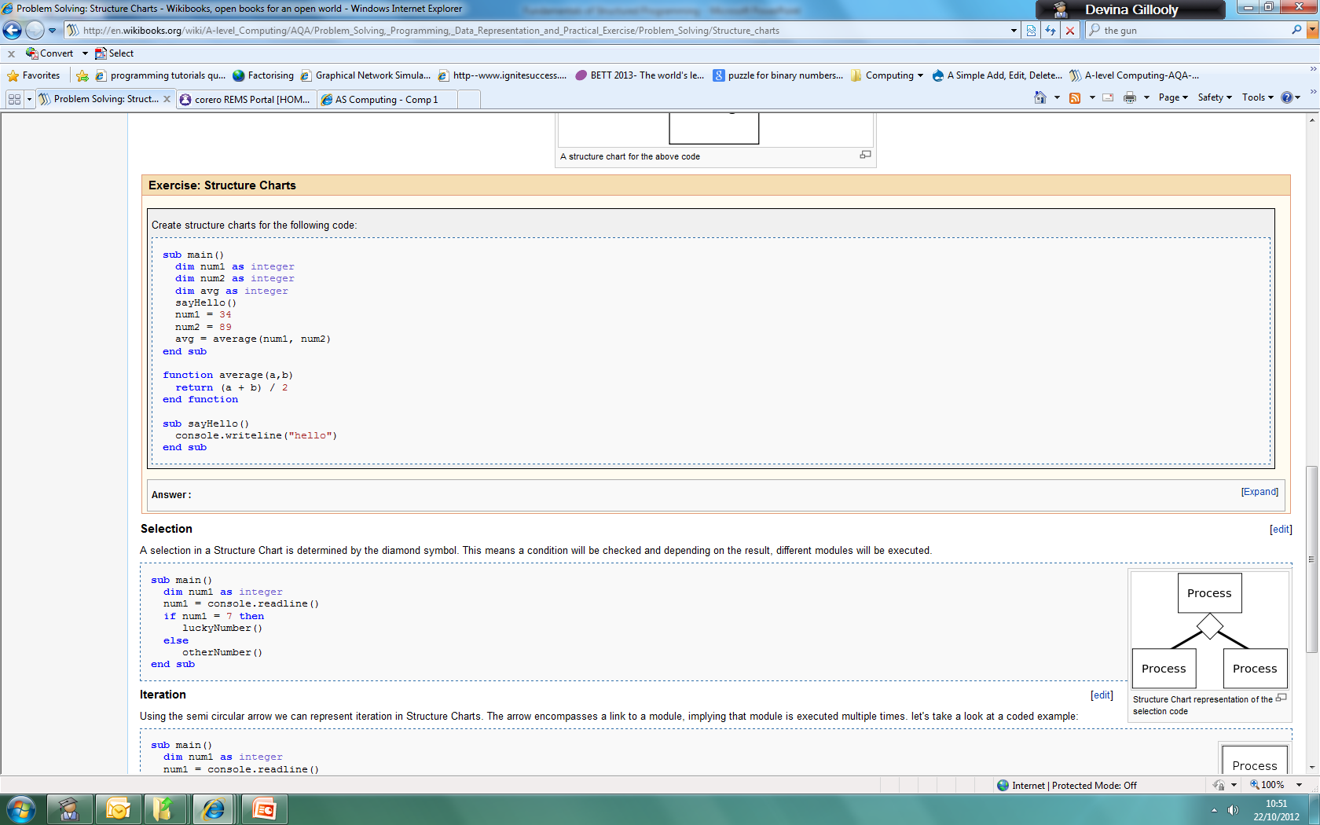

***Discuss & decide on order of modules and the flow.***

**\*\*Challenge: Now convert the hierarchy chart to a structure chart.**

# Task 2: Write the pseudocode for the structure charts below

**P**

|  |  |
| --- | --- |
| **Structure Chart** | **Pseudocode** |
| Main  num = 7  true false  otherNumber  luckyNumber | ***Discuss when and where to include selection & iteration within pseudocode.*** |
|  |  |

# Task 3: Answer these questions. Remember to pay close attention to the marks.

**I**

1. What does each of the symbols mean when creating a structure chart? (6) [Grade:E]

|  |  |
| --- | --- |
| **Symbol** | **Name** |
| [CPT-Structured Chart Data Couple.svg](http://commons.wikimedia.org/wiki/File:CPT-Structured_Chart_Data_Couple.svg) |  |
| [CPT-Structured Chart Data Couple.svg](http://commons.wikimedia.org/wiki/File:CPT-Structured_Chart_Data_Couple.svg) |  |
| [CPT-Structured Chart Data Couple.svg](http://commons.wikimedia.org/wiki/File:CPT-Structured_Chart_Data_Couple.svg)  [CPT-Structured Chart Data Couple.svg](http://commons.wikimedia.org/wiki/File:CPT-Structured_Chart_Data_Couple.svg) |  |
| e |  |
|  |  |
|  |  |

1. What is the difference between a hierarchy chart & a structured chart? (2) [Grade:D]

**I**

1. What is a structure chart and why do we use them? (2) What does each box represent? (1) [Grade:D]
2. Produce a hierarchy and structure chart for a simple hotel system that can accept bookings (name and number of nights), edit bookings and print an invoice. (10) [Grade:C]

|  |  |
| --- | --- |
|  |  |

1. What are the benefits of structured programming? (4) [Grade:B]
2. Why do we put things into procedures and functions? (1) [Grade:B]
3. **Once you have watched this video** [**http://www.youtube.com/watch?v=P6DmhBnQR_4**](http://www.youtube.com/watch?v=P6DmhBnQR_4) **to understand how to draw a structure chart from pseudocode, you need to create a structure chart for the following code: [Grade:A]**

|  |  |
| --- | --- |
| sub howManyThrees()  dim num1, count, total as integer  num1 = startMsg()  count = 0  total = 0  while num1 > 0 do  checkNumber(count, total, num1)  num1 = num1 - 1  end while  endMsg(count)  end sub    sub checkNumber(byRef c, byRef t, byVal n)  If n MOD 3 = 0 Then  c = divBy3(c)  Else  t = add(n, t)  EndIf  end sub    function divBy3(x)  return x + 1  end function    function add(n, t)  return n + t  end function    function startMsg()  console.writeline("program started, enter your number")  return console.readline()  end function    sub endMsg(n)  console.writeline("number of threes : " & n)  end sub |  |